Task 1 - Getting started with moqups.com account setup and tools overview

1. Create a free account in moqups.com. Follow with the click on the a Create a Free Account. You can get this screen. Let’s go with Sign up with Google.

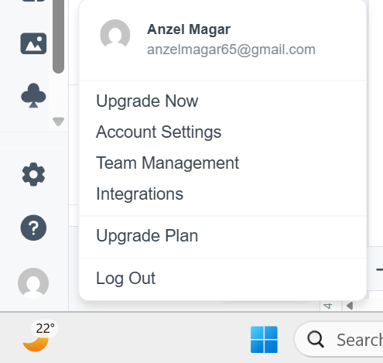

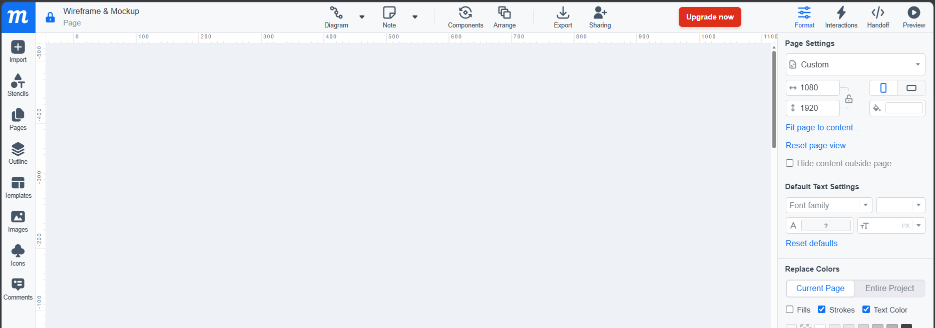
2. You will see this screen. Select Blank Project & Rename as “Wireframe & Mockup”

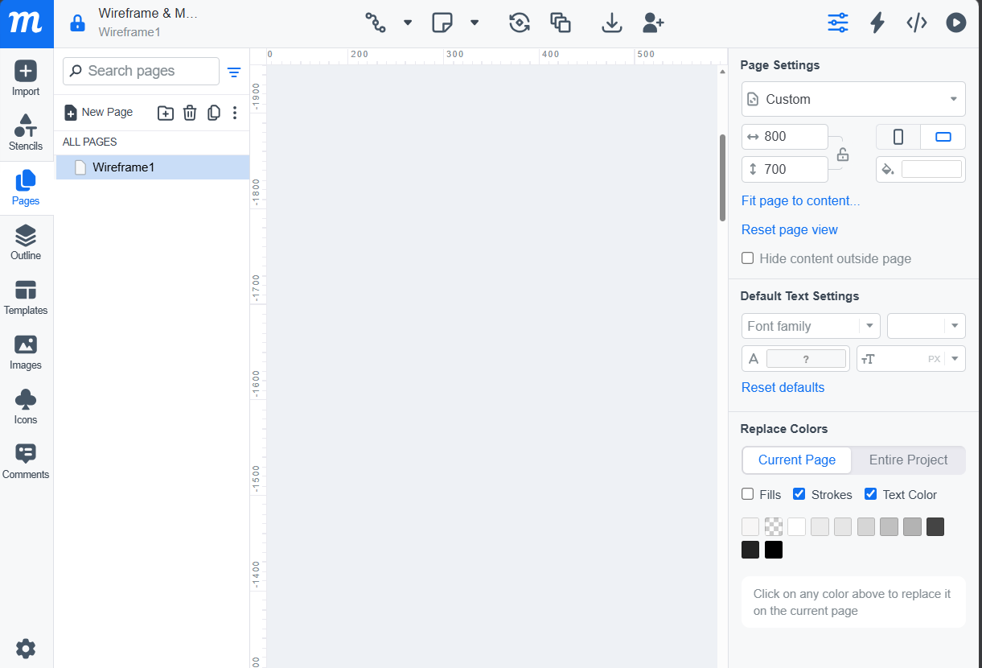

Task 2 – Design the wireframe structure. Use your own creativity.

Moqups Link:
https://app.moqups.com/bdbunA1Vm2ItUBNnFK65r8XcQYBKAVPl/view/page/a69d7d33b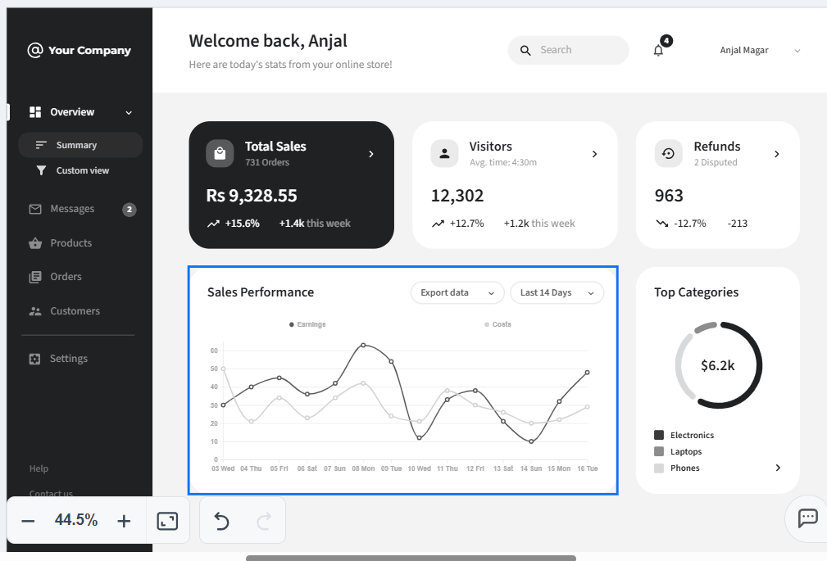
Task 3 – Create a mockup design like your college website’s contact us page. Use your own
creativity for this design.

Moqups Link:
https://app.moqups.com/bdbunA1Vm2ItUBNnFK65r8XcQYBKAVPl/view/page/a039193a0

